**S1: Different Types of Specifications and Their Sections**

Specifications are essential documents in project management and software development. They outline the expectations, requirements, and standards for a project, ensuring that all stakeholders have a clear understanding of what needs to be achieved.

**1. Functional Specifications**

* **Purpose**: Describe the functionality of the system or product, detailing what it is supposed to do. Functional specifications are user-centric and focus on what the system will provide to the end-users.
* **Sections**:
  + **Introduction**: An overview of the document’s purpose, scope, and intended audience.
  + **System Overview**: A high-level description of the system’s objectives and features.
  + **Functional Requirements**: Detailed requirements outlining specific system behaviors, such as “The system shall allow users to log in using their email and password.”
  + **Use Cases**: Scenarios demonstrating how different users will interact with the system.
  + **User Interface Requirements**: Descriptions of what the user interfaces will include and how they will function, often supported by wireframes or prototypes.
  + **Data Requirements**: Information about the types of data the system will manage, including inputs, outputs, and data storage requirements.
  + **Assumptions and Constraints**: Conditions assumed to be true for the system's operation and limitations that may affect the design.

**2. Non-Functional Specifications**

* **Purpose**: Define the system’s operational qualities and constraints, such as performance, security, and usability, which are crucial for meeting the overall user satisfaction and system efficiency.
* **Sections**:
  + **Performance Requirements**: Metrics on speed, availability, and response times. Example: “The system shall respond to user actions within 2 seconds under normal load conditions.”
  + **Security Requirements**: Details on how the system will protect data and prevent unauthorized access. Example: “All data transmission shall be encrypted using SSL.”
  + **Usability Requirements**: Standards for user interaction, accessibility, and overall user experience. Example: “The application must be accessible to users with visual impairments, following WCAG 2.1 standards.”
  + **Scalability Requirements**: Ability of the system to grow and handle increased load without performance degradation.
  + **Reliability and Maintainability Requirements**: Expectations for system uptime and ease of maintenance. Example: “The system must have a 99.9% uptime with scheduled maintenance windows.”

**3. Technical Specifications**

* **Purpose**: Provide the technical details required for building and deploying the system, intended for the development and IT teams.
* **Sections**:
  + **Architecture Overview**: High-level design of the system architecture, including diagrams and descriptions of components, modules, and their interactions.
  + **Technology Stack**: Specification of the technologies, programming languages, frameworks, and tools that will be used. Example: “The system will use JavaScript with React for the front end, Node.js for the backend, and MongoDB for the database.”
  + **Integration Points**: Details on how the system will interface with other systems, APIs, and external services.
  + **Deployment Requirements**: Instructions on the environment setup, including server configurations, database setups, and continuous integration/continuous deployment (CI/CD) pipelines.
  + **Testing and Validation**: Specifications on how the system will be tested, including types of tests (unit, integration, performance), test environments, and success criteria.

**4. Business Requirements Document (BRD)**

* **Purpose**: Outline the business needs, objectives, and high-level requirements of the project, serving as a bridge between the business stakeholders and the technical team.
* **Sections**:
  + **Executive Summary**: A concise summary of the project’s purpose, objectives, and expected outcomes.
  + **Business Objectives**: The specific goals the business aims to achieve with the project. Example: “Increase online sales by 20% within the first year of launching the new platform.”
  + **Scope**: Clearly defines what is included and excluded from the project to prevent scope creep. Example: “The project scope includes a new e-commerce website, but excludes mobile app development.”
  + **Stakeholder Analysis**: Identification of key stakeholders, their roles, and their needs or expectations.
  + **Requirements**: High-level business requirements that define what the system must accomplish to meet the business goals.
  + **Risks and Assumptions**: Potential risks that could impact the project and assumptions made during the planning phase. Example: “Assume that the existing customer database is fully compatible with the new system.”

**5. User Requirements Specification (URS)**

* **Purpose**: Define what the end-users need from the system, focusing on user goals and interactions.
* **Sections**:
  + **User Profiles**: Detailed descriptions of the different user types who will interact with the system.
  + **User Goals**: What each user type aims to achieve with the system.
  + **User Stories**: Narratives describing specific needs from the user’s perspective.
  + **Acceptance Criteria**: Specific conditions that must be met for the user needs to be considered fulfilled.
  + **Usability and Accessibility Requirements**: Specific needs related to ease of use and accessibility for all user types.

**S2: Key Items – Capabilities, Business Processes, User Personas, User Stories, and Requirements**

**1. Capabilities**

**Definition**: Capabilities describe the high-level functions or characteristics that the system must possess to fulfill business goals. They represent what the system can do without getting into detailed requirements.

**Examples**:

* For a **Customer Relationship Management (CRM)** System:
  + **Capability**: Manage customer interactions and data across various channels.
  + **Explanation**: This capability allows sales and support teams to have a unified view of customer interactions, enhancing customer service and sales opportunities.
* For an **Inventory Management System**:
  + **Capability**: Track inventory levels in real-time across multiple locations.
  + **Explanation**: This helps businesses maintain optimal stock levels, reduce stockouts, and minimize overstock.

**Interconnection**: Capabilities guide the definition of business processes by outlining what needs to be achieved at a higher level, ensuring that the detailed processes align with the overarching business goals.

**2. Business Processes (Three Levels)**

**Definition**: Business processes describe a series of steps or activities that a business performs to achieve a specific goal. These are typically broken down into three levels:

* **Strategic Level**: High-level processes that align with the company’s mission and strategic goals.
  + **Example**: “Develop new product lines to capture emerging market segments.”
  + **Explanation**: Strategic processes are driven by the company’s vision and long-term goals and are often linked to major initiatives or transformations.
* **Tactical Level**: Mid-level processes that translate strategic goals into actionable plans within departments or teams.
  + **Example**: “Conduct market research to identify customer needs for new product lines.”
  + **Explanation**: Tactical processes focus on how specific departments contribute to strategic objectives. They are more detailed than strategic processes but still operate at a high level.
* **Operational Level**: Day-to-day activities that keep the business running and ensure the execution of tactical plans.
  + **Example**: “Process daily customer feedback reports to adjust product features.”
  + **Explanation**: Operational processes are the most detailed, representing routine actions performed by employees to support tactical goals.

**Interconnection**: Strategic processes define the direction of the business, tactical processes outline how strategic goals will be achieved, and operational processes execute the specific tasks required to meet tactical plans. Together, they ensure that all activities are aligned with the company’s overall mission.

**3. User Personas**

**Definition**: User personas are fictional but data-driven representations of different user types who might use the system. They capture user needs, goals, behaviors, and pain points, guiding the design and development process to ensure the system meets user expectations.

**Example**:

* **Persona**: Alex, a 35-year-old project manager at a tech company who values efficiency and clear communication.
  + **Goals**: Quickly set up new projects, assign tasks, and monitor progress in real-time.
  + **Frustrations**: Slow-loading software, complicated navigation, lack of integration with other tools.
  + **Behaviors**: Frequently uses project management tools on both desktop and mobile devices, prefers dashboards that provide a quick overview.

**Explanation**: Personas help prioritize features and design elements that are most important to the target users. They serve as a reference point throughout the development process, ensuring that the final product resonates with its intended audience.

**Interconnection**: Personas influence user stories by providing a clear understanding of who the users are, what they need, and why they need it. This ensures that requirements are user-centered and aligned with real-world scenarios.

**4. User Stories**

**Definition**: User stories are concise, simple descriptions of a feature told from the perspective of the user. They focus on what the user needs and why, allowing developers to build functionality that delivers value.

**Example**:

* **User Story**: “As a project manager, I want to be able to generate reports on project progress so that I can provide updates to stakeholders.”
* **Acceptance Criteria**:
  + The report should include task completion status, team performance, and project timelines.
  + The report should be downloadable in PDF and Excel formats.
  + Users should be able to filter reports by date range, team, and project status.

**Explanation**: User stories break down user needs into actionable development tasks, providing clear guidance on what to build and how it will benefit the user. Acceptance criteria further define the conditions that must be met for the story to be considered complete.

**Interconnection**: User stories provide the details that translate high-level capabilities and requirements into specific, testable development tasks. They ensure that every aspect of the system is developed with the user’s needs in mind.

**5. Requirements**

**Definition**: Requirements are detailed descriptions of what the system must do (functional requirements) or how it must behave (non-functional requirements). They provide the foundation for system design and development, ensuring that the system meets business needs and user expectations.

**Examples**:

* **Functional Requirement**: “The system must allow users to upload and store files up to 5 GB in size.”
* **Non-Functional Requirement**: “The system must be available 99.9% of the time, excluding scheduled maintenance.”

**Interconnection**: Requirements derive from business processes, user personas, and user stories. Functional requirements often map directly to user stories, while non-functional requirements ensure that the system meets broader performance, security, and usability standards. Together, they provide a comprehensive view of what the system must achieve and how it must perform.

**Summary of Interconnections**

Understanding the interconnections between capabilities, business processes, user personas, user stories, and requirements is crucial for successful project execution. Here’s how they link together:

* **Capabilities** set the stage by defining what the system must broadly achieve.
* **Business Processes** detail the steps necessary to meet strategic, tactical, and operational goals, guided by the system’s capabilities.
* **User Personas** provide insight into who the users are and what they need, ensuring that the system’s design and functionality align with real user behaviors and preferences.
* **User Stories** translate user needs into actionable tasks, providing a clear path from user requirements to system features.
* **Requirements** encompass both functional and non-functional aspects, detailing exactly what the system must do and how it must perform.

By aligning all these elements, the project team can ensure that the system not only meets business and user needs but also delivers a cohesive and efficient user experience.

**1. Business Process Model and Notation (BPMN) Diagram**

**Definition**: BPMN diagrams are used to model the steps of a business process from start to finish. They provide a standard way to visualize internal business procedures with a graphical notation and are widely used to improve efficiency, identify bottlenecks, and align processes.

**Example**:

* **Scenario**: A customer placing an online order.
* **Diagram Elements**: Start Event, Task (e.g., “Enter Order”), Gateway (e.g., “Payment Confirmation”), End Event.
* **Flow**:
  + Customer starts the order (Start Event).
  + Fills in order details (Task).
  + Proceeds to payment (Task).
  + Payment is verified (Gateway).
  + If payment is successful, order confirmation is sent (End Event).
  + If payment fails, the customer is asked to retry (Gateway loops back to payment).

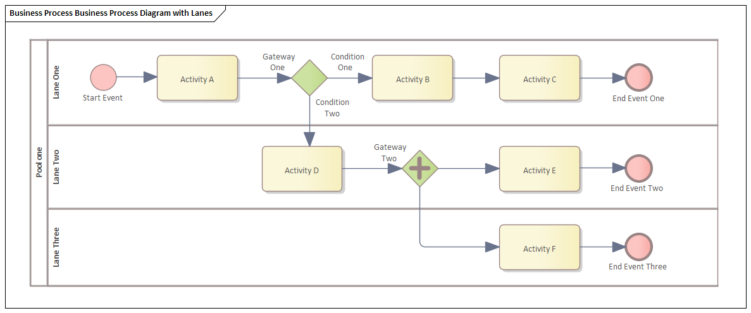

What are the four categories of BPMN?

BPMN symbols fall under four main areas: flow objects, connecting objects, artifacts, and swimlanes.

**Flow objects**

BPMN flow symbols are the elements that connect and form the process flow. They include the following:

Events - An event represents something that happens in the process. received” event could be represented by a pile of coins or a dollar bill.

Activities- Activities appear in a BPMN diagram as a rounded rectangle. They represent the parts of the process that require action

**Connecting objects**

These are the connection lines and arrows that symbolize how objects relate to each other and how the process flows from one activity to the next. Here are some of the different connecting objects:

**Artifacts**

Artifacts provide supporting information about your business processes. They allow you to describe elements of the process and help to categorize and organize tasks.

**Swimlanes**

Swimlanes are a key part of a BPMN diagram’s structure. They’re typically horizontal, rectangular boxes that separate different stages of the process.

**2. Use Case Diagram**

**Definition**: Use Case Diagrams depict the interactions between users (actors) and the system to achieve a goal. They provide a high-level view of what the system will do and who will interact with it.

**Example**:

* **Scenario**: An e-commerce website.
* **Actors**: Customer, Admin.
* **Use Cases**: “Search for Products,” “Place Order,” “Manage Inventory.”
* **Diagram**:
  + Customer -> (Search for Products).
  + Customer -> (Place Order).
  + Admin -> (Manage Inventory).
  + Relationships: Actors interact with their respective use cases.

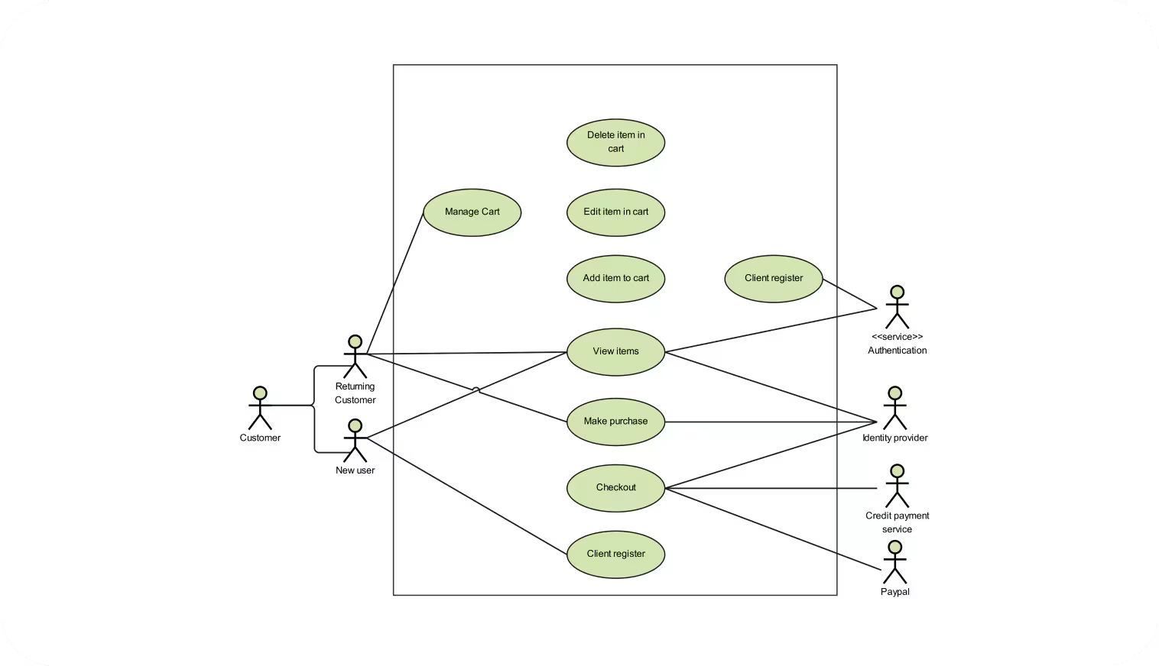

Use case diagrams are usually referred to as behavior diagrams used to describe a set of actions (use cases) that some system or systems (subject) should or can perform in collaboration with one or more external users of the system (actors). Each use case should provide some observable and valuable result to the actors or other stakeholders of the system.

Note, that UML 2.0 to 2.4 specifications also described use case diagram as a specialization of a class diagram, and class diagram is a structure diagram.

Use case diagrams are in fact twofold - they are both behavior diagrams, because they describe behavior of the system, and they are also structure diagrams - as a special case of class diagrams where classifiers are restricted to be either actors or use cases related to each other with associations.

**3. Entity-Relationship (ER) Diagram**

**Definition**: ER Diagrams show the structure of a database by illustrating entities, their attributes, and the relationships between them. An Entity Relationship (ER) Diagram is a type of flowchart that illustrates how “entities” such as people, objects or concepts relate to each other within a system.

**Example**:

* **Scenario**: A university database.
* **Entities**: Student, Course, Enrollment.
* **Attributes**: Student (ID, Name, Age), Course (ID, Title, Credits), Enrollment (Student ID, Course ID, Date).
* **Relationships**:
  + Student “enrolls in” Course (many-to-many).
  + ER Diagram links Student and Course via Enrollment.

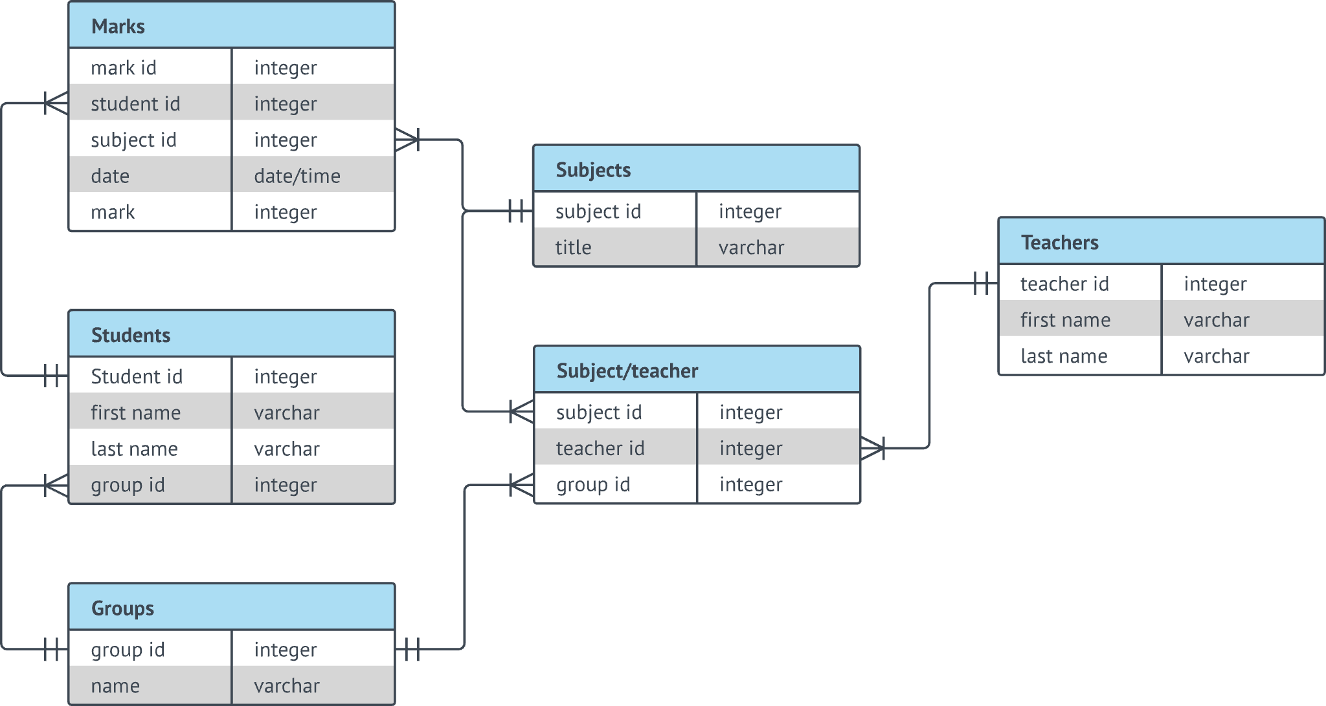

ER Diagrams are most often used to design or debug relational databases in the fields of software engineering, business information systems, education and research. Also known as ERDs or ER Models, they use a defined set of symbols such as rectangles, diamonds, ovals and connecting lines to depict the interconnectedness of entities, relationships and their attributes. They mirror grammatical structure, with entities as nouns and relationships as verbs.

**4. Data Flow Diagram (DFD)**

**Definition**: DFDs represent how data moves through a system, illustrating processes, data stores, data flows, and external entities. They help identify data inputs, outputs, and processes within a system.

**Example**:

* **Scenario**: A payroll system.
* **Processes**: “Calculate Pay,” “Generate Payslip.”
* **Data Stores**: Employee Records, Payslip Archive.
* **External Entities**: Employee, Bank.
* **Data Flows**:
  + Employee provides work hours (input).
  + System calculates pay (Process).
  + Payslip is generated and stored (Data Store).
  + Payslip is sent to Bank (Output).

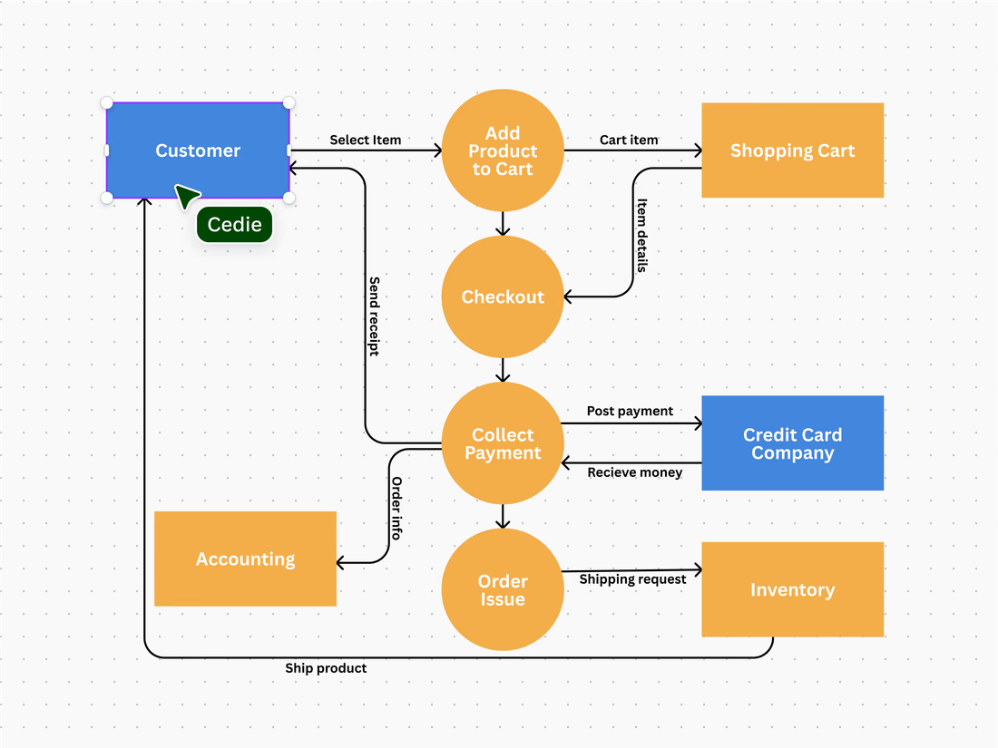

**5. Wireframe or Mockup Diagram**

**Definition**: Wireframes are low-fidelity, simplified layouts of web or app interfaces. They focus on functionality and structure rather than visual design.

**Example**:

* **Scenario**: A new landing page for a website.
* **Elements**: Header, Navigation Bar, Main Content Area, Footer.
* **Wireframe**:
  + Placeholder for logo and navigation at the top.
  + Main content section with text boxes and image placeholders.
  + Footer with contact details and social media links.

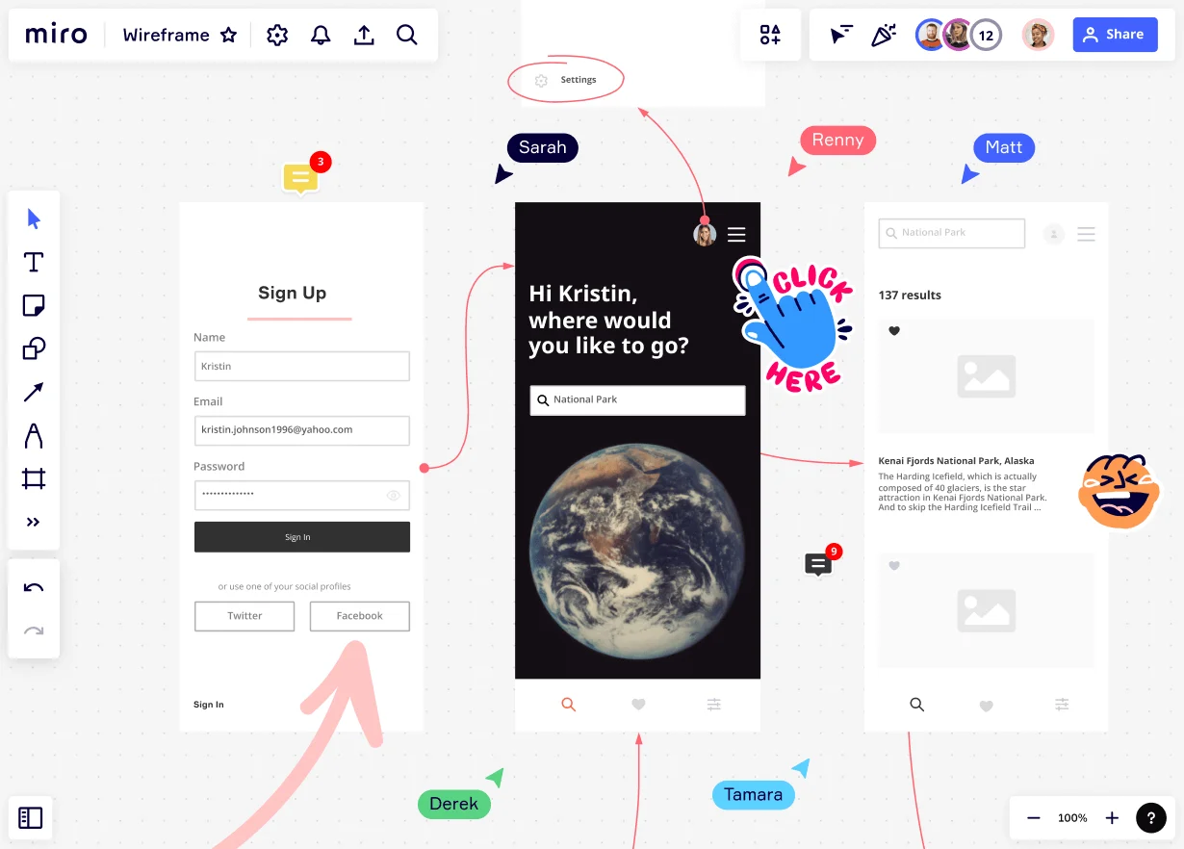

A wireframe is a visual diagram that outlines the skeletal framework of a website, app, or other digital product. Sometimes known as a page schematic or screen blueprint, it demonstrates how elements relate to each other and how they’re structured. By using a

wireframe tool

to build a blueprint, designers can create consistent layouts that meet user needs.

Wireframing is a top-level process.

User experience (UX) designers

often use it to map out the design and layout of their work without going into too much detail. It’s the first stage of the design process before it is fleshed out to add more detail. As such, a wireframe primarily focuses on functionalities and intended behaviors, but not color schemes or final stylistic choices.

**6. Swimlane Diagram (Cross-Functional Flowchart)**

**Definition**: Swimlane diagrams split tasks into lanes to represent different actors, departments, or systems, showing responsibilities and interactions in a process.

**Example**:

* **Scenario**: Processing a loan application.
* **Lanes**: Customer, Loan Officer, Underwriting Department, Legal Department.
* **Flow**:
  + Customer submits application (Customer Lane).
  + Loan Officer reviews application (Loan Officer Lane).
  + Application is evaluated by Underwriting (Underwriting Lane).
  + Contract is prepared and signed (Legal Lane).

A swim lane diagram, sometimes called a cross-functional diagram, is a process

flowchart that provides richer information on who does what. It can also be

expanded to show times—when tasks are done and how long they take. As

seen in a swim lane diagram of ARC Community Services’ intake process

(FIGURE 4), the visual metaphor is a swimming pool, with each participant in the

process assigned to “lanes.”

The steps to create a swim lane diagram follow:

1. Focus on a specific process, and put the title of your diagram on top.

2. Enumerate the people involved in this process and assign them to rows, typically

beginning with the customer on the top row.

3. Create the process flowchart, drawing processes and decisions made, as well as

arrows that indicate the process flow.

4. If the diagram is too complex, break it up into its components. As seen in

FIGURE 4, the diagram indicates phases or sub-processes (i.e., pre-intake,

intake, pre-treatment, treatment, etc.).

5. If possible, indicate times for each node on the bottom of the diagram. Compute

cumulative totals—the total time elapsed—within each phase.

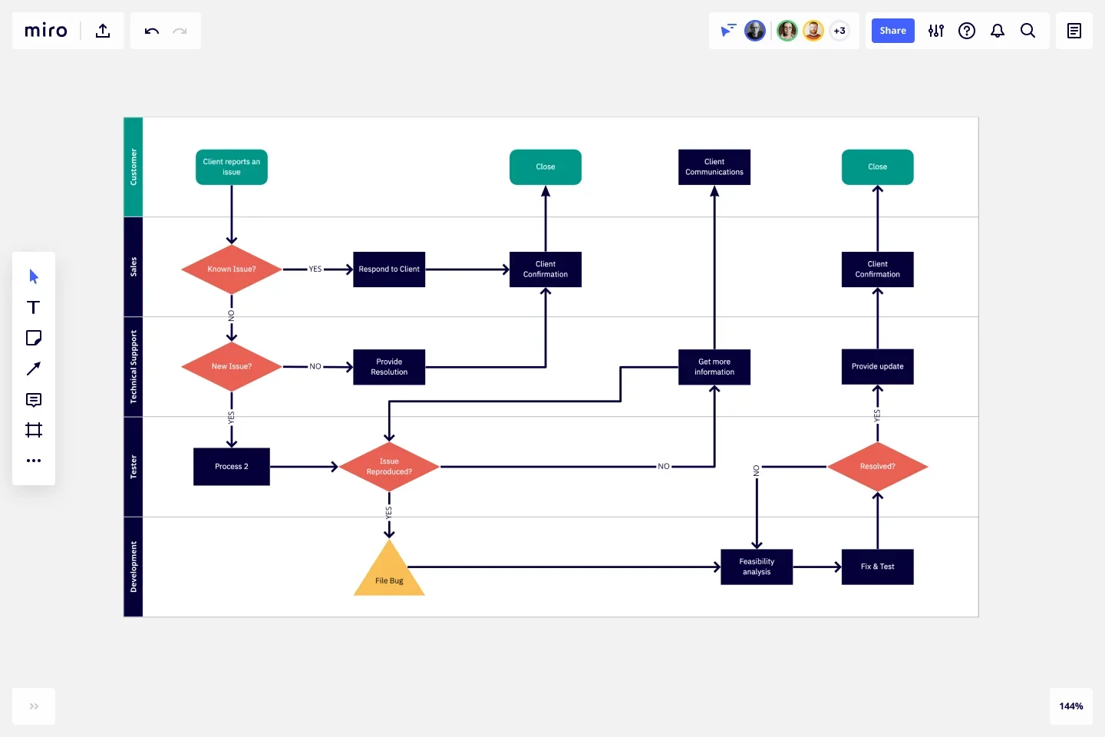

**7. Gantt Chart**

**Definition**: Gantt charts are project management tools that illustrate the start and finish dates of elements within a project. They help in scheduling, tracking progress, and resource allocation.

**Example**:

* **Scenario**: Software Development Project.
* **Tasks**: Requirements Gathering, Design, Development, Testing, Deployment.
* **Timeline**:
  + Requirements (Weeks 1-2).
  + Design (Weeks 3-4).
  + Development (Weeks 5-8).
  + Testing (Weeks 9-10).
  + Deployment (Week 11).
* Each task is represented as a bar, aligned with the timeline.

A Gantt chart, or harmonogram, is a bar chart that graphically illustrates a schedule for planning, coordinating, and tracking specific tasks related to a single project.

Even a century after its introduction, the Gantt chart continues to be an important tool in project and program management. Described in 1999 as “one of the most widely used management tools for project scheduling and control.”

The anatomy is straightforward: Tasks appear on the vertical axis, and time intervals, or activity duration, appear along the horizontal axis.

These charts are commonly used by teams in construction, consulting, marketing, manufacturing, HR, software development, and event planning.

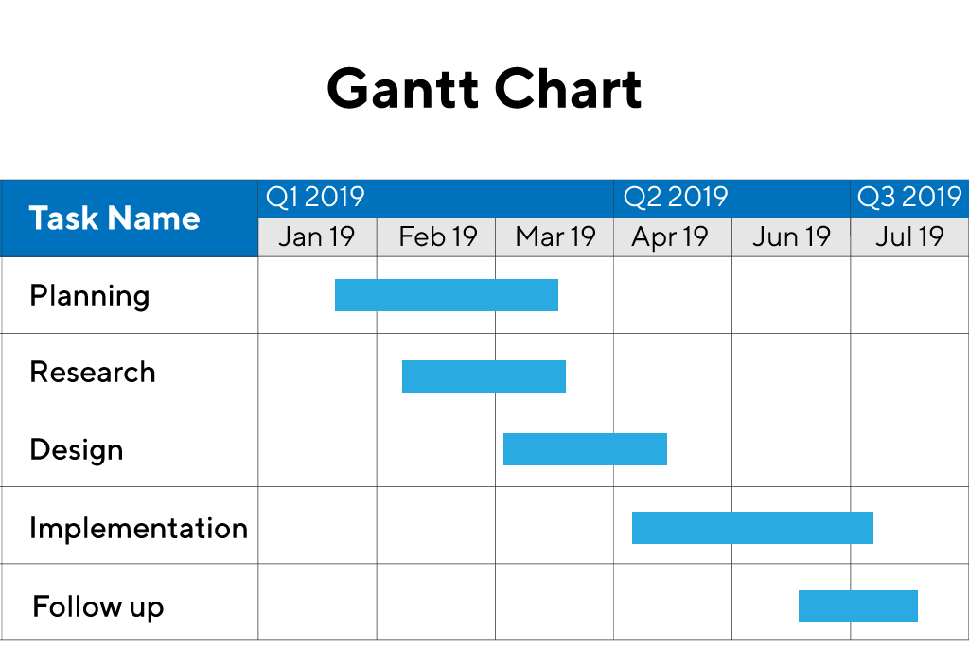

**8. Stakeholder Map**

**Definition**: A Stakeholder Map identifies all the key stakeholders of a project and their interests, influence, and involvement. It helps in understanding who to communicate with and manage expectations.

**Example**:

* **Scenario**: Launching a new product.
* **Stakeholders**: Customers, Marketing Team, Sales Team, Product Development, Investors.
* **Map**:
  + Customers: High interest, low influence.
  + Investors: High interest, high influence.
  + Product Development: High influence, high interest.

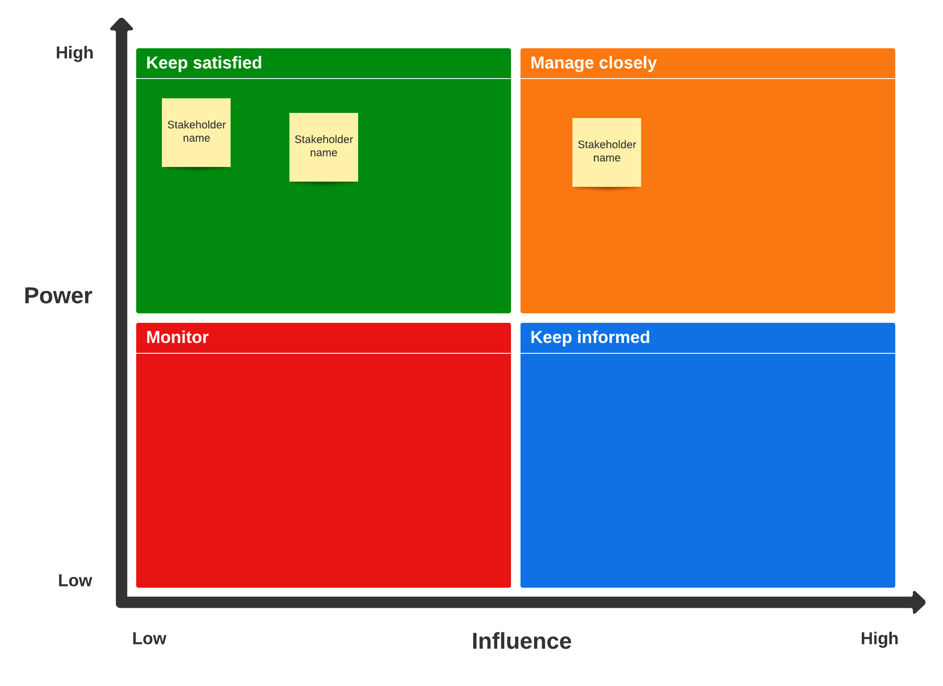

**9. State Diagram**

**Definition**: State diagrams represent the various states of an object and the transitions between these states, typically used in system design to model dynamic behavior.

**Example**:

* **Scenario**: A user account system.
* **States**: Created, Active, Suspended, Closed.
* **Transitions**:
  + Account is created (Created -> Active).
  + Account is suspended due to inactivity (Active -> Suspended).
  + Account is closed upon request (Active/Suspended -> Closed).

A state diagram (also known as a state machine or statechart diagram) is an illustration of all the possible behavioral states a software system component may exhibit and the various state changes it's predicted to undergo over the course of its operations.

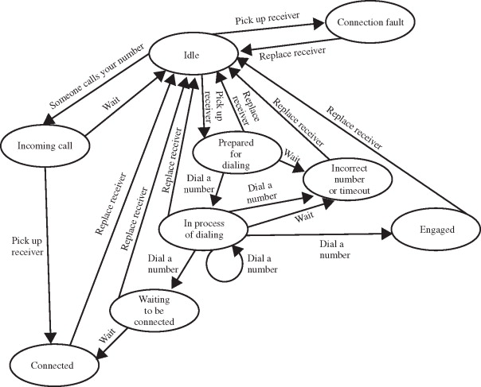

**10. Requirement Traceability Matrix (RTM)**

**Definition**: RTMs link requirements to their corresponding test cases, ensuring each requirement is tested and tracked throughout the development lifecycle.

**Example**:

* **Scenario**: A new feature in an app.
* **Requirements**: “User can reset password.”
* **Test Cases**: “Test password reset via email,” “Test reset link expiry.”
* **Matrix**:
  + Maps Requirement ID to Test Case IDs.
  + Tracks status (Pass/Fail).

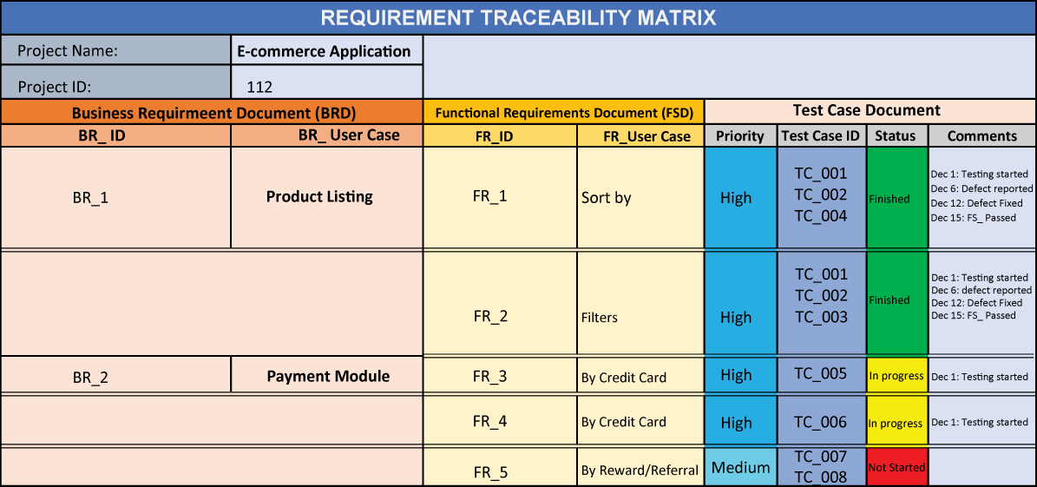

The Requirements Traceability Matrix (RTM) is a tool or a document that helps project managers establish and track the project progress. It helps monitor deliveries by providing a digital thread for each demand from the beginning to the end of the project. This guarantees that the scope and deliverables of the project are in line with the baseline.

Traceability Matrix is used in different phases of the project lifecycle, such as

The Requirements Analysis and Specification phase

Design Analysis and Specification phase

Risk Analysis phase

Source Code Analysis, Unit Testing & Integration Testing phase

Validation – System Testing, Functional Testing phase

**11. Gap Analysis Diagram**

**Definition**: Gap Analysis identifies the gap between current performance and desired goals, providing a basis for improvement plans.

**Example**:

* **Scenario**: Analyzing software performance.
* **Current State**: 70% uptime.
* **Desired State**: 99.9% uptime.
* **Gap**: 29.9%.
* **Action Plan**: Upgrade servers, implement better monitoring tools.

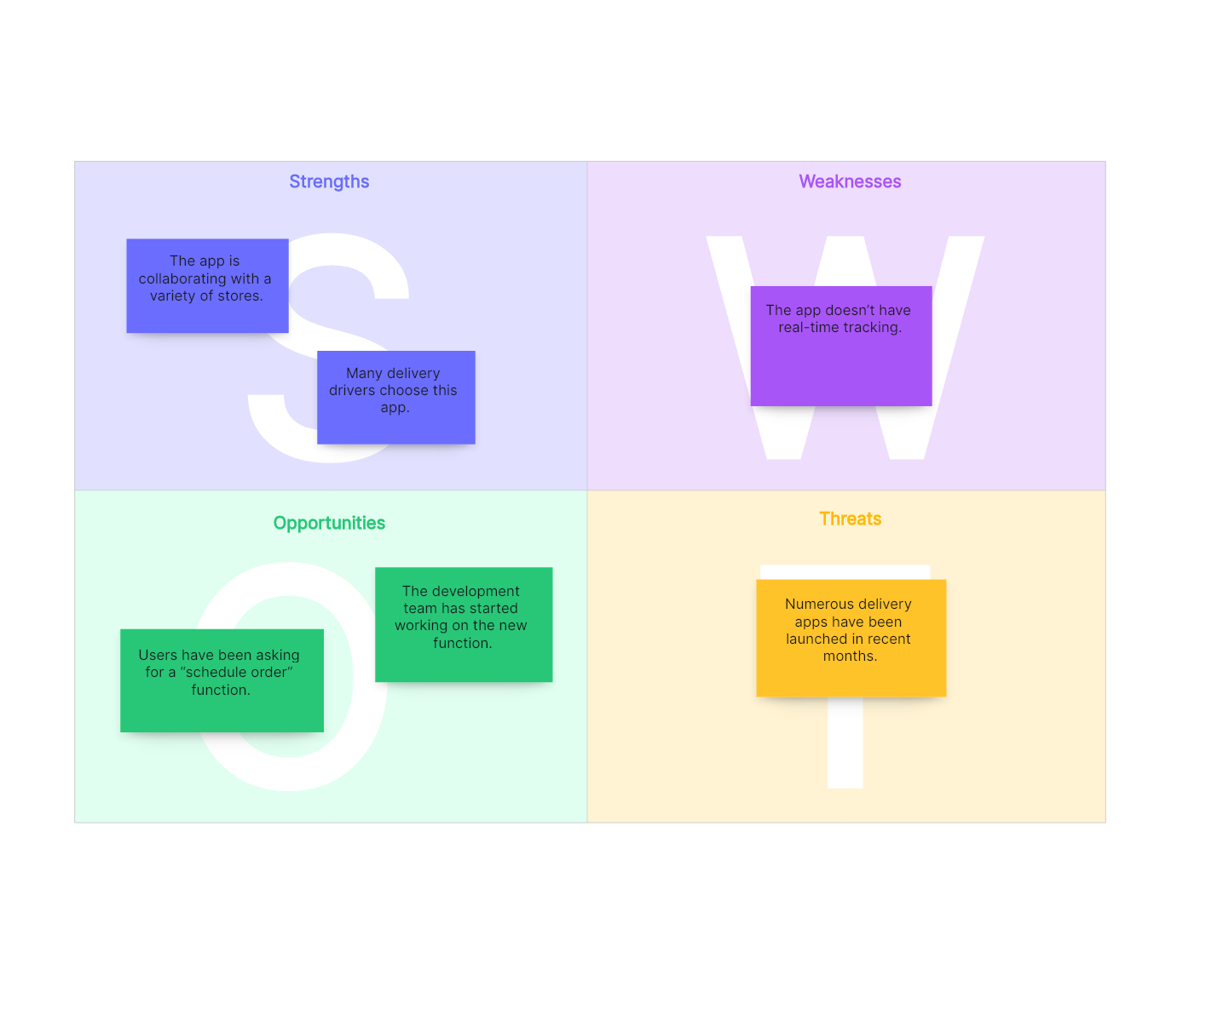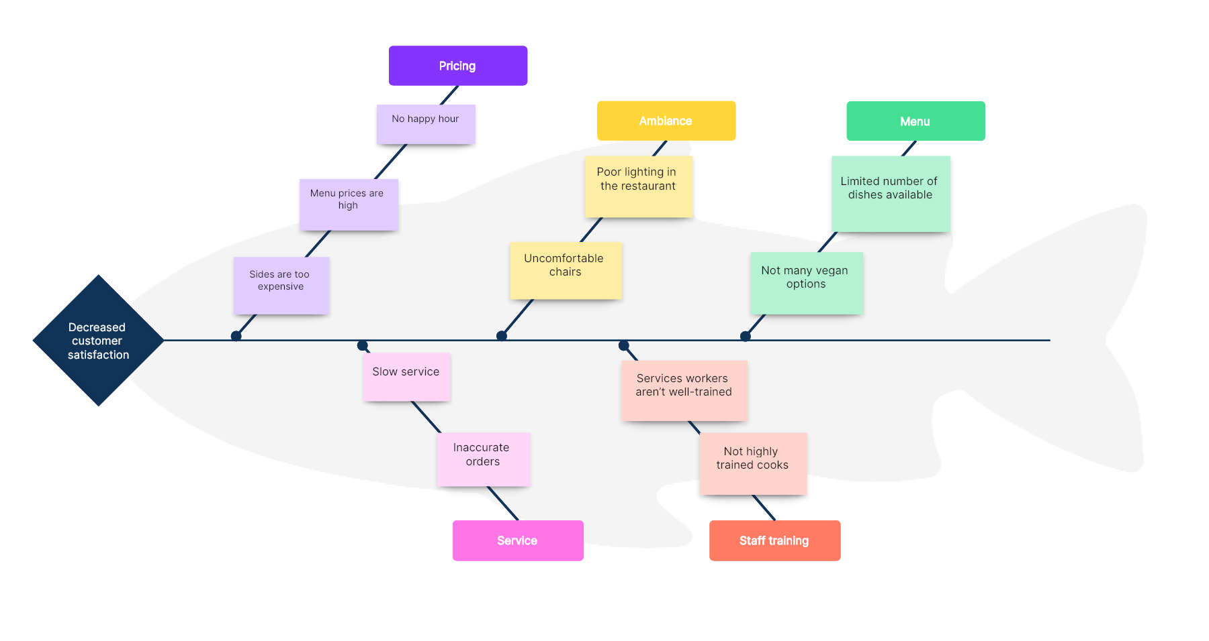

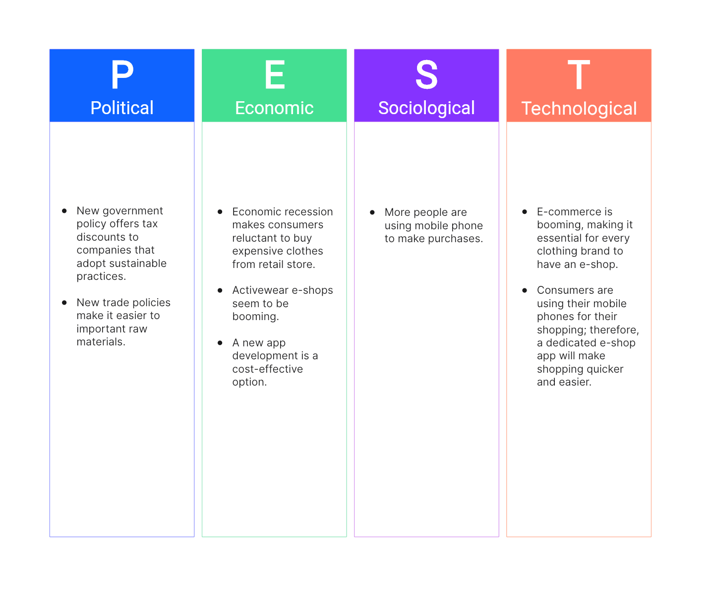

**12. Activity Diagram**

**Definition**: Activity diagrams represent the flow of activities in a system or process, often used to model workflows, operations, or use cases.

**Example**:

* **Scenario**: User registration process.
* **Activities**: “Fill Registration Form,” “Submit Form,” “Validate Data,” “Send Confirmation Email.”
* **Flow**:
  + User fills the form (Start).
  + Form is submitted (Transition).
  + Data is validated (Decision).
  + If data is valid, a confirmation email is sent (End).

Activity diagrams show the workflow from a start point to the finish point detailing the many decision paths that exist in the progression of events contained in the activity

